1-Lexical item

📘 What is a Lexical Item?
# Source: Chatgpt (GPT-4-turbo) at [7/23/2025]
A lexical item (also called a lexeme) is a unit of meaning in a language. It can be:
- a single word (like book),
- a compound word (like blackboard),
- or a multi-word expression (like kick the bucket or in front of).

🧠 Key Idea:
# Source: Chatgpt (GPT-4-turbo) at [7/23/2025]
A lexical item is any unit in the vocabulary of a language that has its own meaning and behaves like a single word in how it functions in a sentence.

🔍 Examples of Lexical Items:
# Source: Chatgpt (GPT-4-turbo) at [7/23/2025]
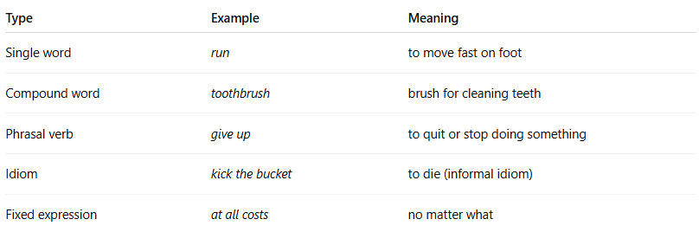

Type | Example | Meaning
Single word | run | to move fast on foot
Compound word | toothbrush | brush for cleaning teeth
Phrasal verb | give up | to quit or stop doing something
Idiom | kick the bucket | to die (informal idiom)
Fixed expression | at all costs | no matter what

🧾 More Examples:
# Source: Chatgpt (GPT-4-turbo) at [7/23/2025]
- Open lexical items: nouns, verbs, adjectives, adverbs (can add new ones easily)
  - computer, eat, beautiful, quickly
- Closed lexical items: prepositions, conjunctions, pronouns (rarely add new ones)
  - in, but, she

✅ Summary:
# Source: Chatgpt (GPT-4-turbo) at [7/23/2025]
A lexical item is a meaningful unit of vocabulary in a language. It can be a word or a group of words that function as one unit in terms of meaning and grammar.

2-Lexicon

📚 What is a Lexicon?
# Source: Chatgpt (GPT-4-turbo) at [7/23/2025]
A lexicon is the complete set of words (or lexical items) in a language — basically, it's the mental dictionary of a language.

📘 Definition:
# Source: Chatgpt (GPT-4-turbo) at [7/23/2025]
A lexicon is the vocabulary of a language, including its words, their meanings, and sometimes their pronunciation, grammar, and usage.

🧠 Key Points:
# Source: Chatgpt (GPT-4-turbo) at [7/23/2025]
- It includes all the words a language has — from common words to technical or rare ones.
- It may also include:
  - Phrases
  - Idioms
  - Collocations (common word combinations)
  - Word forms and meanings

🔍 Types of Lexicons:
# Source: Chatgpt (GPT-4-turbo) at [7/23/2025]
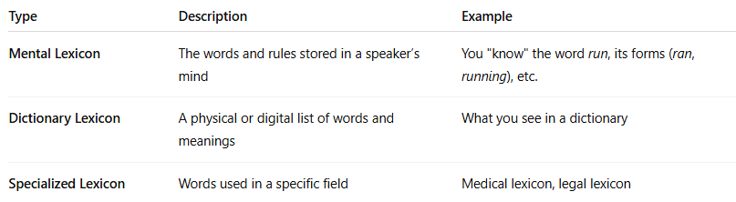

Type | Description | Example
Mental Lexicon | The words and rules stored in a speaker’s mind | You "know" the word run, its forms (ran, running), etc.
Dictionary Lexicon | A physical or digital list of words and meanings | What you see in a dictionary
Specialized Lexicon | Words used in a specific field | Medical lexicon, legal lexicon

🧾 Examples of What's in a Lexicon:
# Source: Chatgpt (GPT-4-turbo) at [7/23/2025]
- Words: book, love, democracy, fast
- Idioms: break the ice, spill the beans
- Word classes: noun, verb, adjective
- Morphological forms: eat, eats, ate, eating

🧬 Lexicon vs. Lexical Item:
# Source: Chatgpt (GPT-4-turbo) at [7/23/2025]


Term | Meaning
Lexicon | The entire vocabulary of a language
Lexical Item | A single word or phrase within that vocabulary

✅ Summary:
# Source: Chatgpt (GPT-4-turbo) at [7/23/2025]
The lexicon of a language is its vocabulary — all the words, phrases, and expressions people use and understand.

3-Lexeme

🔤 What is a Lexeme?
# Source: Chatgpt (GPT-4-turbo) at [7/23/2025]
A lexeme is the base unit of meaning in a language. It’s the abstract form of a word that includes all its grammatical variations (inflected forms), but is treated as one vocabulary item.

📘 Definition:
# Source: Chatgpt (GPT-4-turbo) at [7/23/2025]
A lexeme is a basic unit of meaning in the mental lexicon.
It includes all the word’s inflected forms, which share the same core meaning.

🧠 Key Idea:
# Source: Chatgpt (GPT-4-turbo) at [7/23/2025]
- A lexeme is not just one word form — it’s the whole group of forms that come from the same root.
- It’s like the “dictionary headword” that represents all versions of the word.

🔍 Examples:
# Source: Chatgpt (GPT-4-turbo) at [7/23/2025]
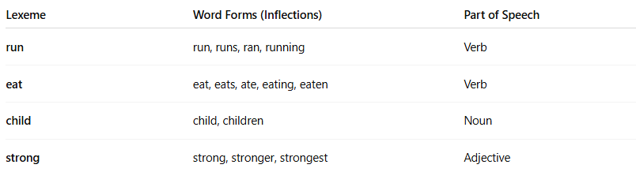
Lexeme | Word Forms (Inflections) | Part of Speech
run | run, runs, ran, running | Verb
eat | eat, eats, ate, eating, eaten | Verb
child | child, children | Noun
strong | strong, stronger, strongest | Adjective
These forms are different word forms, but they all belong to one lexeme.

⚖️ Lexeme vs. Word vs. Lexical Item:
# Source: Chatgpt (GPT-4-turbo) at [7/23/2025]
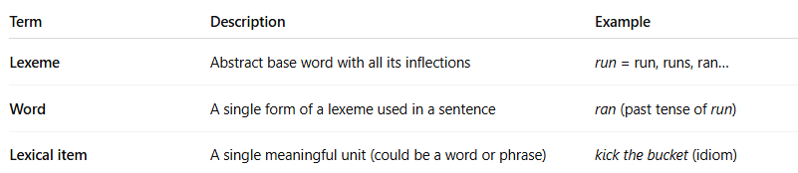
Term | Description | Example
Lexeme | Abstract base word with all its inflections | run = run, runs, ran…
Word | A single form of a lexeme used in a sentence | ran (past tense of run)
Lexical item | A single meaningful unit (could be a word or phrase) | kick the bucket (idiom)

✅ Summary:
# Source: Chatgpt (GPT-4-turbo) at [7/23/2025]
A lexeme is the base word concept that covers all its grammatical forms (like run, ran, running = 1 lexeme).
It’s a key concept in morphology and dictionary structure.

